Last Modified: 9-4-2007 |  | 1.6 C
Service Category: Audio/Visual/Telematics | Section: Park Assist/Monitoring
Model Year: 2008 | Model: Land Cruiser | Doc ID: RM000003AHC000X
Title: PARK ASSIST / MONITORING: INTUITIVE PARKING ASSIST SYSTEM: C1AEC: Front Sensor Communication Malfunction (2008 Land Cruiser)

DTC | C1AEC | Front Sensor Communication Malfunction

DESCRIPTION
This DTC is stored when there is an open or short circuit in the communication line between the front sensors and the ECU, or when there is a malfunction in a front sensor.
DTC CODE | DTC DETECTION CONDITION | TROUBLE AREA
C1AEC | An open or short circuit in the communication line between the front sensors and ECU or a malfunction in a front sensor during initialization mode after the engine switch is turned on (IG). | - Front ultrasonic sensor circuit  - Clearance warning ECU

WIRING DIAGRAM
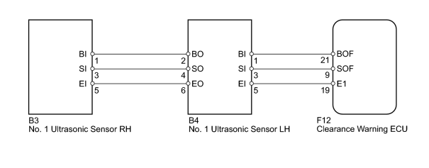

INSPECTION PROCEDURE

PROCEDURE
1. | CHECK DTC OUTPUT
(a) Clear the DTCs .
(b) Check for DTCs .

Result
RESULT | PROCEED TO
DTC C1AEC is output | A
No DTC is output | B

B |  | USE SIMULATION METHOD TO CHECK

A

2. | CHECK CLEARANCE WARNING ECU
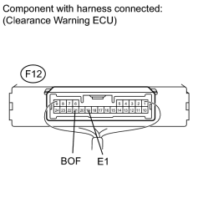
(a) Measure the voltage according to the value(s) in the table below.
Standard Voltage:
TESTER CONNECTION | CONDITION | SPECIFIED CONDITION
F12-21 (BOF) - Body ground | Engine switch on (IG) | 7.2 to 8.8 V
(b) Measure the resistance according to the value(s) in the table below.
Standard Resistance:
TESTER CONNECTION | CONDITION | SPECIFIED CONDITION
F12-19 (E1) - Body ground | Always | Below 1 Ω

NG |  | REPLACE CLEARANCE WARNING ECU

OK

3. | CHECK HARNESS AND CONNECTOR (NO. 1 ULTRASONIC SENSOR LH - CLEARANCE WARNING ECU)
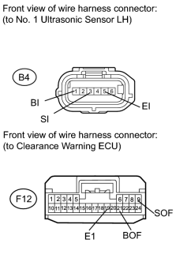
(a) Disconnect the B4 sensor connector.
(b) Disconnect the F12 ECU connector.
(c) Measure the resistance according to the value(s) in the table below.
Standard Resistance:
TESTER CONNECTION | CONDITION | SPECIFIED CONDITION
B4-1 (BI) - F12-21 (BOF) | Always | Below 1 Ω
B4-3 (SI) - F12-9 (SOF) | Always | Below 1 Ω
B4-5 (EI) - F12-19 (EI) | Always | Below 1 Ω
B4-1 (BI) - Body ground | Always | 10 kΩ or higher
B4-3 (SI) - Body ground | Always | 10 kΩ or higher
B4-5 (EI) - Body ground | Always | 10 kΩ or higher

NG |  | REPAIR OR REPLACE HARNESS OR CONNECTOR

OK

4. | CHECK HARNESS AND CONNECTOR (NO. 1 ULTRASONIC SENSOR LH - NO. 1 ULTRASONIC SENSOR RH)
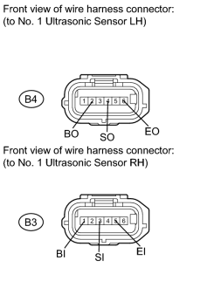
(a) Disconnect the B4 and B3 sensor connectors.
(b) Measure the resistance according to the value(s) in the table below.
Standard Resistance:
TESTER CONNECTION | CONDITION | SPECIFIED CONDITION
B4-2 (BO) - B3-1 (BI) | Always | Below 1 Ω
B4-4 (SO) - B3-3 (SI) | Always | Below 1 Ω
B4-6 (EO) - B3-5 (EI) | Always | Below 1 Ω
B4-2 (BO) - Body ground | Always | 10 kΩ or higher
B4-4 (SO) - Body ground | Always | 10 kΩ or higher
B4-6 (EO) - Body ground | Always | 10 kΩ or higher

NG |  | REPAIR OR REPLACE HARNESS OR CONNECTOR

OK

5. | CHECK DTC OUTPUT
(a) Clear the DTCs .
(b) Check for DTCs .

Result
RESULT | PROCEED TO
DTC C1AEC is output and multi-information display indicates open circuit (Front Left and Front Right) | A
No DTC is output | B

B |  | USE SIMULATION METHOD TO CHECK

A

6. | REPLACE NO. 1 ULTRASONIC SENSOR LH
(a) Replace the No. 1 ultrasonic sensor LH with a normally functioning sensor .
NEXT

7. | CHECK DTC OUTPUT
(a) Clear the DTCs .
(b) Check for DTCs .

Result
RESULT | PROCEED TO
DTC C1AEC is output | A
No DTC is output | B

B |  | END (NO. 1 ULTRASONIC SENSOR LH IS DEFECTIVE)

A

8. | REPLACE NO. 1 ULTRASONIC SENSOR RH
(a) Replace the No. 1 ultrasonic sensor RH with a normally functioning sensor .
NEXT

9. | CHECK DTC OUTPUT
(a) Clear the DTCs .
(b) Check for DTCs .

Result
RESULT | PROCEED TO
DTC C1AEC is output | A
No DTC is output | B

B |  | END (NO. 1 ULTRASONIC SENSOR RH IS DEFECTIVE)

A |  | REPLACE CLEARANCE WARNING ECU

